LINUX COMMANDS

- ls: List files and folders in the current directory

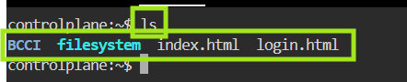

- touch index.html: Create an empty file named index.html
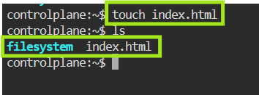

- vi login.html: Open login.html in the vi editor to type content

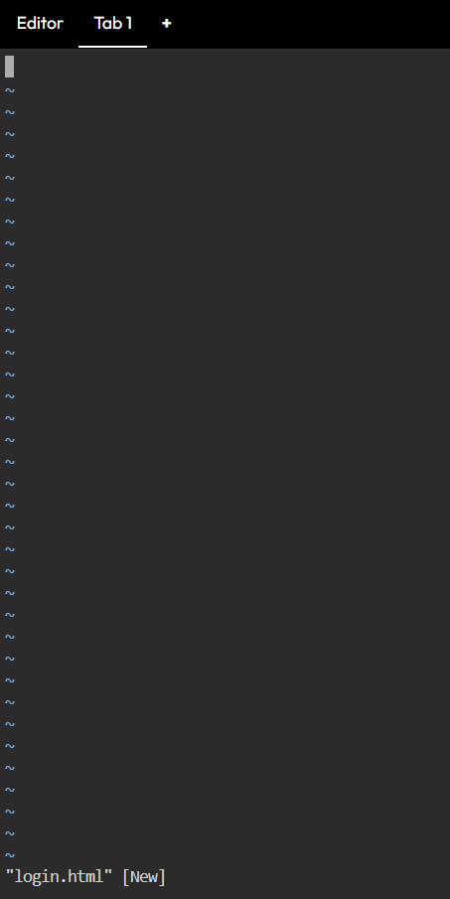
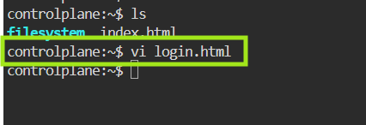

- mv login.html ranjana.html: Rename file
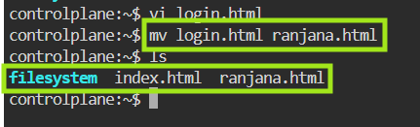

- cat ranjana.html: Display content of renamed file
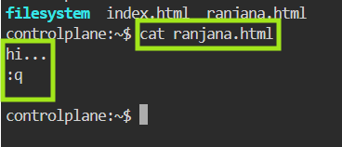

- mv index.html demo.html: Rename index.html → demo.html

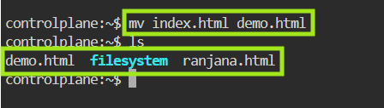
- mkdir wipro-devops-training: Create a directory

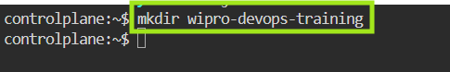
- mkdir DevOps: Create another directory

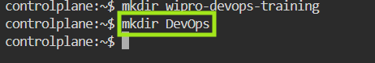
- cd DevOps/: Enter DevOps directory
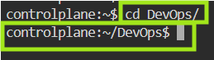 inside DevOps folder

- pwd: Show current directory path
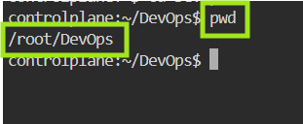
- touch git docker: Create two empty files
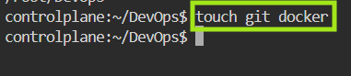
- mkdir kubernetes terraform ansible: mkdir kubernetes terraform ansible
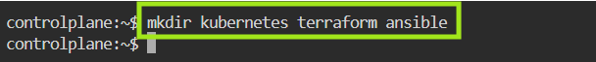
- cd ..: Move one directory back
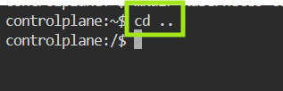
- touch demo app sample: Create 3 empty files
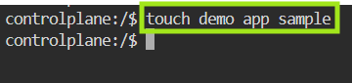
- cd ../..: Go back two directories
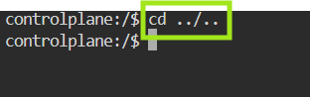
- wget apache-tomcat-9.0.115.exe: Download file from the internet
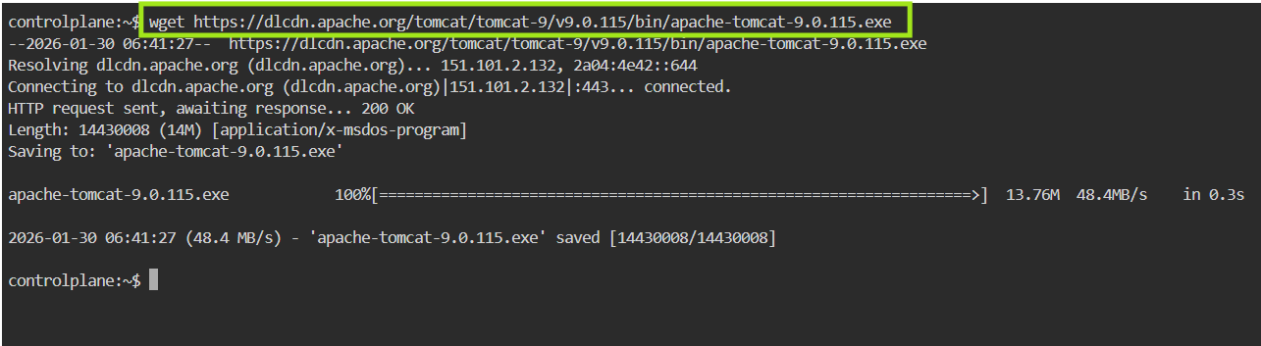
- ping www.google.com: Check internet connectivity
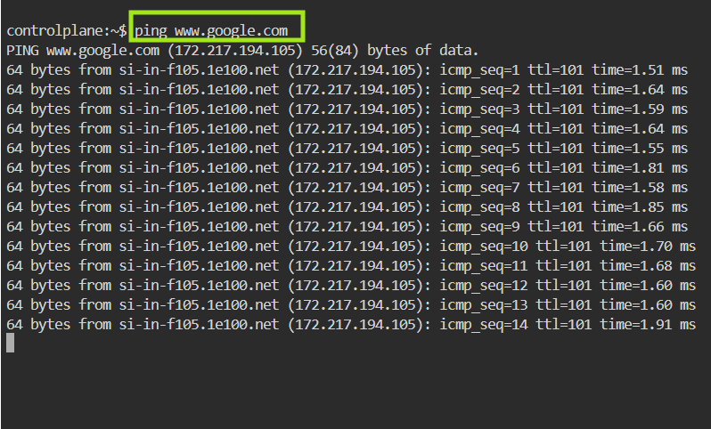
- history: Show all previously executed commands
